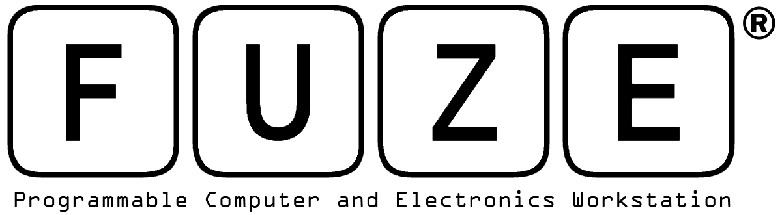

FUZE Workshops at Guildford Code Camp

Aylesbury, UK, FUZE Technologies Ltd, creator of the FUZE workstation powered by the Raspberry Pi and paired with FUZE BASIC have announced that they are to sponsor the Babcock Code Camp in Guildford at the end of July.

The Babcock Code Camp is a computing course for primary, secondary and special schools. Running from the 29th to the 30th July 2014 and based around the changes to the National Curriculum in England: Computing Programmes of Studies. The FUZE workshops will provide teachers with enough skills, resources and knowledge to create an outstanding computing curriculum for their school.

This will enable attendees to network with likeminded professionals and collaborate to produce schemes of work and activities to inspire students and classes.
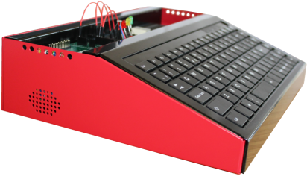
“We are really excited about sponsoring the Babcock Code Camp” Jon Silvera, Managing Director of FUZE Technologies Ltd. “We have put together some key workshops for all teachers attending which showcases how easy it is to use the FUZE as a teaching and learning tool.”

The FUZE workshops aim to demystify some of the terminology of the new National Curriculum, allowing the attendees to experience for themselves, by programming with FUZE BASIC, that the subject is so much more interesting and exciting than it first appears.

The FUZE brings to life all the key stages of the National Curriculum computing programmes of study in a fun, motivational and engaging package for the classroom, after school clubs, extra-curricular projects and home coders.

At Code Camp teachers will, in addition to learning how to use FUZE BASIC, see how they can enhance their teaching of programming with the FUZE curriculum compliant lesson plans and the FUZE BASIC Project cards. Particularly as the Project cards promote collaborative and child initiated learning and contain easily measurable success criteria.

The FUZE is extremely robust and secure and by operating at a very low DC voltage provides an exceptionally safe environment. Making it more than a match for the rigours of everyday school life, not to mention protecting the Raspberry Pi from electronic shorting, static and physical damage so extending its life and use within the classroom. As many schools have invested in the Raspberry Pi the FUZE is available either with or without the Pi, allowing schools to make the most of the investment they have already made.

The FUZE interactive electronic kit helps to develop programming skills and an understanding of practical applications of technology in the real world. The kit, contains a solder-less breadboard (used to create temporary prototypes and experiment with circuit design) and an array of jumper cables/wires, resistors, LED’s, micro switches and a buzzer.

The Guildford Code Camp will take place on 29th and 30th July at Guildford Schools’ Training Center, Larch Avenue, Guildford, GU1 1JY.

For more information on the FUZE please visit www.fuze.co.uk

For more information on Guildford Code Camp please visit: http://webfronter.com/surreymle/Code_Camp/

About the FUZE
UK based FUZE Technologies Ltd has its roots in home computers and programming. Our many years of experience in the computer industry and our passion for IT innovation and computer programming have positioned us perfectly to expand our business into Programmable Computers and Electronics.
FUZE BASIC and the FUZE logo are registered trademarks of FUZE Technologies Ltd.
Back to BASIC – Why?
BASIC (Beginner’s All-purpose Symbolic Instruction Code)
In the late seventies and early eighties The BASIC programming language captured and nurtured millions of bedroom coders across the entire globe. These programmers went on to evolve and develop just about every aspect of the computing industry as we know it today. Of course this is a generalisation but it’s no exaggeration to say that without the BASIC language things would have been very different today. While programming today is far from the simple environments of the eighties the core programming principles remain the same. Variables, Conditional and logical statements, Loops, Memory management, BIT & Byte manipulation, file management and Input/Output are all introduced in FUZE BASIC and are far easier to grasp in its easy-to-understand language and framework. It therefore remains the ideal platform to learn, and for that matter teach, computer programming to all ages and abilities.
About the Raspberry Pi
Raspberry Pi® and the Raspberry Logo are trademarks of the Raspberry Pi Foundation and are used with permission. For more information we recommend visiting the home of the Raspberry Pi at; http://www.raspberrypi.org.

CONTACT DETAILS

FUZE Technologies Ltd.
www.fuze.co.uk
+44 (0) 1844 239 432

